TEACHER’S PROFILE

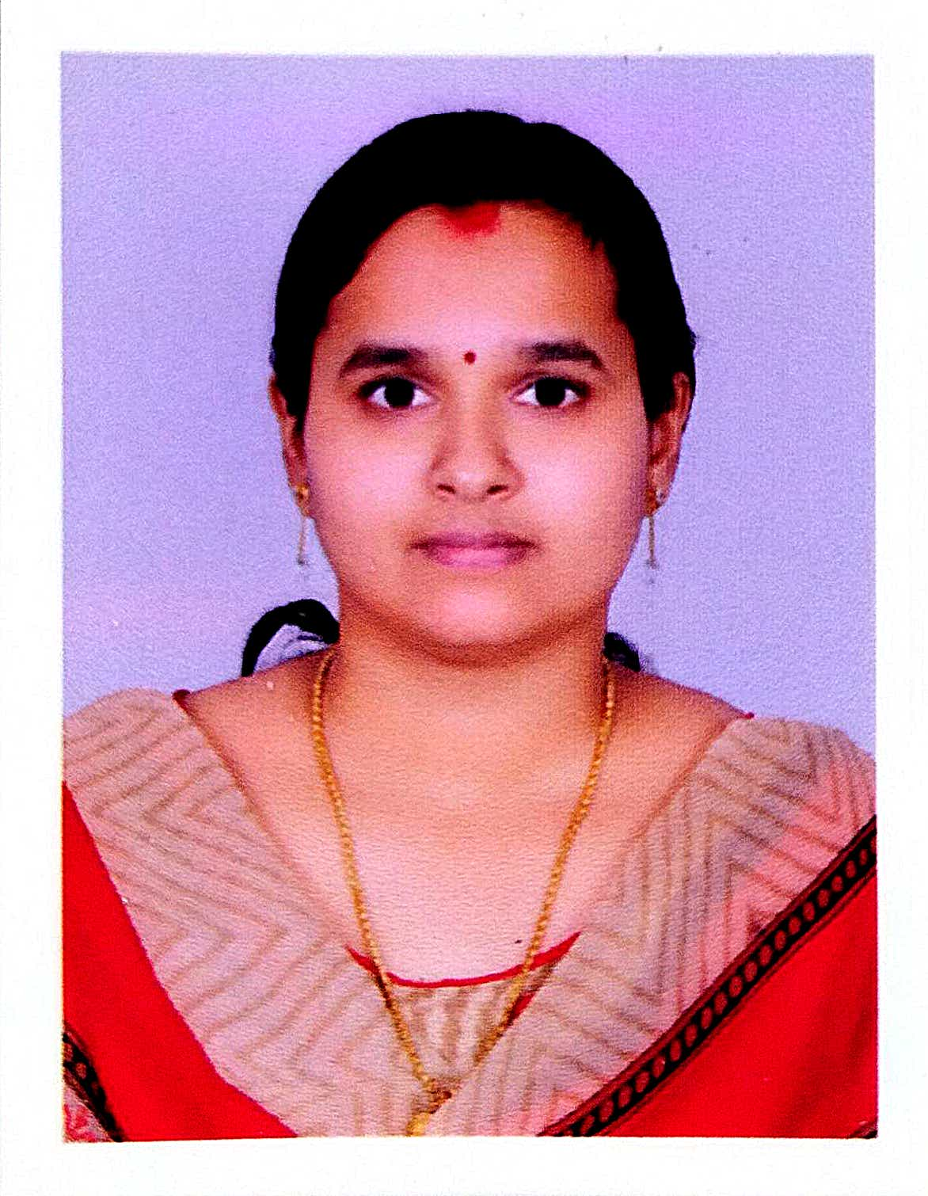
- GENERAL INFORMATION

NAME | JYOTHI K K
DESIGNATION | ASSISTANT PROFESSOR
QUALIFICATION | M A, B.Ed, NET
RESEARCH | DOING
CONTACT NO | 9745474254
E-MAIL ID | jyothisasi1983@gmail.com
Any other

- EDUCATIONAL QUALIFICATIONS
Course | Board/University | Institution | Year | Remarks
SSLC | Board of Public Exams, Kerala | S K P H S Sreekrishnapuram | 1998 | First class
Plus two | Board of HSE, Kerala | GHSS, Vellinazhi | 2000 | First Class
B A Economics | University of Calicut | M E S Kalladi College, Mannarkkad | 2003 | First Class
M A Economics | University of Calicut | M E S Kalladi College, Mannarkkad | 2005 | First Class with Third rank
B.Ed (Social Science) | University of Calicut | N S S Training College, Ottapalam | 2011 | First Class
NET | UGC |  | 2011
Ph.D | University of Calicut | JMC Aranattukara, Thrissur | Doing | Registered in 2018
- RESEARCH DETAILS
PhD (Part time)
Title | The Changing Pattern of Housing In Rural Kerala: A study of Palakkad District
Guide | Dr. Ramachandran K V
No. & Date of Regisration | U.O.No.14228/2018/Admn, 05-11-2018
University | University of Calicut
Date of Submission of Thesis | 04-11-2024
Awarded or Not | Doing
- SERVICE DETAILS
Date of Joining in the Govt Service | 24-10-2016
Date of Joining in the Present Post | 24-10-2016
PEN | 785888
SDO Code
Additional Charges | I M A Tutor
Additional Duties

- ORIENTATION AND REFRESHER COURSES ATTENDED

Year | Course | Date (from- to) | Duration | University
2016-17
2017-18 | Induction Programme (1 Month) | 02/05/2018 - 31/05/2018 | 30 Days | MHRD TLC University of Calicut
2018-19
2019-20
2020-21 | ARPIT Refresher Ccourse in Economics | 01-12-2020 -31-03-2021 | 4 months | SWAYAM ( Shri Ram College of Commerce)
2021-22 | Short Term Course on Research Ethics and Methodology  FDP- Applied Econometrics | 11.08.2021 -17.08.2021  Jul-Oct 2021 | 1 week  12 week | UGC-HRDC University of Calicut  NPTEL  (Ministry of HRD, GoI)

- SEMINARS/WORKSHOPS PARTICIPATED
Year | Seminar/Work Shop (Sponsoring Agency) | Topic | Date&Year | Institution
2016-17 | International Seminar | Socio economic Perspectives of Women Enterpreneurship in Kerala | 08-12-2016 | Department of Economics, Mercy College Palakkad
2017-18 | National Seminar(DCE) | OneNation, One Tax and One Market : Impact and Implications of GST in India | 26/10/2017 to 27/10/2017 | Department of Economics Govt College Chittur Palakkad
 | National Seminar(DCE) | Debates on Indian Macro Economics | 18/12/2017 to 19/12/2017 | Department of Economics SNGS College Pattambi.
 | Capacity Building Programme (IMG) | Capacity Building Programme for Assistant professors of Collegiate education Department | 22/01/2018 to 24/01/2018 | Institute of Management in Government, Thiruvananthapuram.
 | work shop (IQAC) | work shop on Effective Class Room Teaching | 01-02-2018 | IQAC, Govt College Chittur Palakkad
2018-19 | National Work Shop(DCE) | Multivariate Analysis in Social Science Research | 13/09/2018 to 15/09/2018 | Department of Commerce, Govt College Chittur Palakkad
 | National Seminar(DCE) | Structural Transformation in the Indian Economy: Trends, Patterns and implications | 30/10/18 to 31/10/18 | Department of Economics, SNGS College, Pattambi.
 | National Seminar(DCE) | Implications of Environmental Economics on Restructuring Kerala | 22/11/2018 to 23/11/2018 | Department of economics, Govt College, Chittur Palakkad
 | International Seminar | Money, Growth and Macro Economic Policies in India | 17/01/2019-19/01/2019 | Department of Economics, JMC, Aranattukara, Thrissur
 | International conference | Challenges of Digital Business in the new millennium | 12-11-2018 | School of Management Studies Dr John Matthai Centre Regional Campus, University of Calicut Thrissur
2019-20 | National Workshop(DCE) | Quantitative Techniques and Explorations in Social Science Research | 16/10/2019-18/10/2019 | Department of Economics, Govt Victoria College, Palakkad
 | National Seminar(DCE) | Time of Serious Economic Turmoil: Role of Economics and Economists | 28/10/2019-29/10/2019 | SNGS College, Pattambi
 | National Workshop(DCE) | Estimation Procedures And Statistical Inferences In Social Science Researches | 11/12/2019-13/12/2019 | Department Of Economics, Govt. College, Chittur
 | International Seminar (NABARD) | “ Monetary policy Debates: The Slowdown Scenario” | 12/02/20 to 13/02/20 | NSS College, Ottapalam
2020-21 | Management Development Programme (DCE) | “Training Programme on Pedagogy” | 02-03-2021 to 04-03-2021 | IIM Kozhikode
2021-22 | Webinar | “Statistics: Scientific Developments in New Directions” | 28-02-2022 | Department of Statistics, S N G S College, Pattambi

- ACHIEVEMENTS IN ACADEMIC ACTIVITIES OTHER THAN TEACHING AND RESEARCH
Publication details
- “Economic Empowerment through SHGs with special Reference to Kerala”, Women Enterpreneurship an overview, Abhijeet Publication, 2017, Edited Book, ISBN978-93-5074-268-6 Pp: 258-267

- “Potential of Sericulture”, Kurukshetra Journal of Rural Development, ISSN 0021-5660, Journal on Rural Development, Central Government Journal- Ministry of Rural Development, Vol. No.14, No.1 66.No.6 April2018, Pp 54-58

- “Impact and Incidence of Disaster Management with special reference to Kerala Floods”, jiggyAsA, Vol No.1 JAN-DEC 2018, ISSN 2249-3298, Pp 12-27

- “Impact of Flood on Housing Sector of Kerala Economy”, Sustainable Development- Impact and Incidence, AUTHORS PRESS 2019, Edited book, ISBN 978-93-89110-61-6 Pp 161-168

- “Housing in Kerala: An overview of Structural and Technological Composition” jiggyAsA, Vol No.15 No. 1, JAN-DEC 2019, ISSN 2249-3298, Pp45-51

- “Housing in Urban Kerala: Prospects and Challenges”, Urban Panorama, Jul-Dec 2021, Vol.XX. No.2 ISSN 0975-8534 Pp 59-70

