TEACHERS PROFILE
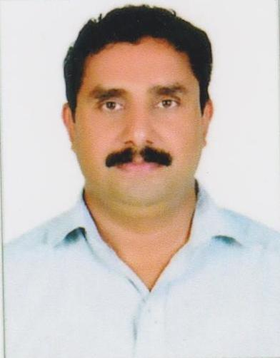

- General Information
Name | SASIKUMAR P
Designation | Asst. Professor
Qualification | MA, B Ed, NET
Research
Contact No. | 8089897778
E-mail ID | skmanissery@gmail.com
Any Other

- Educational Qualifications

Course | Board/University | Year | Remarks
S S L C | Board of Public Exams., Kerala | 1989
Pre Degree | University of Calicut | 1991
B A English | University of Calicut | 1996
M A English | University of Calicut | 2001
B Ed  (English) | University of Calicut | 2007
NET | UGC | 2000

C Research Details

 | Ph.D
Title | SPACE, PLACE AND MAPPING IN FICTION: A GEOCRITICAL  STUDY OF SELECT NOVELS OF ANITA NAIR
Guide | Dr. Yoosaph A.K., Assistant Professor, Department of English, Govt.  College, Mokeri, Kozhikode
No. & Date of Registration | U.O.No. 8524/2017/Admn  Dated, Calicut University.P.O, 10.07.2017
University | Calicut University
Date of Submission of thesis | Not Submitted
Awarded or Not

D SERVICE DETAILS

Date of Joining in the Govt. service | 05/06/1998
Date of Joining in the present post | 08/08/2014
PEN | 323184
Additional charges | RTI – State Public Information Officer  Coordinator- National seminar- 2015-16

- Orientation & Refresher Courses Attended

Details of Orientation & Refresher/Research Methodology/Short Term Course attended
Name of the Course | Duration and Date | Name of the Centre conducting the Course | Sponsoring Agency
Soft Skills  Refresher Course | 12 weeks  29th July 2019  to 18 Oct 2019 | IIT Roorkee | SWAYAM-NPTEL Online Course
Annual Refresher Programme in English Language Teaching (ARPIT)  Refresher Course | 16 weeks  01 Oct 2019 to  31 Dec 2019 | Gujarat University | NPTEL – UGC - SWAYAM
Induction Programme  (Orientation Programme) | 30 Days  From 28-09-2020  to 27-10-2020 | UGC-Human Resource Development Centre (HRDC)University Of Kerala | UGC

- SEMINARS/WORKSHOPS PARTICIPATED

Year | Name of the workshop/ seminar | Organizing Institution/ Department | Date From – To
2015 - 16 | National Seminar - Diasporic Reflections: An Intermingling of Cultural and Subaltern Perspectives | Dept of English,  SNGS College, Pattambi | 29/10/2015 - 30/10/2015
2015 -16 | Resistance Literature in Colonial Malabar | Dept of History,  SNGS College, Pattambi | 07/01/2016
2016 - 17 | National Seminar: Nation, Body and Performance | Dept of English,  SNGS College, Pattambi | 12/01/2017 - 13/01/2017
2017 -18 | National Seminar - Auto Fiction and Local History | Dept of History,  SNGS College, Pattambi | 14/12/2017 -15/12/2017
2018-19 | National Seminar - Theorizing Theory: Post Modern and After | Dept of English,  SNGS College, Pattambi | 25/10/2018 - 26/10/2018
2019 - 20 | Natiuonal Workshop - Literary Research : Designs and Methodology | Dept of English,  SNGS College, Pattambi | 11/11/2019 - 12/11/2019
2019-20 | ‘Ideology, ‘Otherness’, and Tolerance: The Many Pasts of India’ | Dept of History,  SNGS College, Pattambi | 23-24 October 2019.

Achievements in academic activities other than teaching and Research

Publications
A . Research Papers
Title of paper | Name of journal | Year of publication | ISSN number
Cyberculture and Spatial Consciousness in Fiction A Study nof T D Ramakrishnan's Sugandhi Enna Andal Devanayaki | Malayalam Literary Survey (MLS) | 2017 | ISSN 2319 - 3271
Mapping Travels of the Deterritorialized: A Study of Anita Nair's Idris: Keeper of the Light | IMPACT: IJRHAL | 2019 | ISSN (P) : 2347 - 4564 ISSN(E): 2321- 8878
Spatial Identity and Cultural Consciousness in Anita Nair's Idris: Keeper of the Light | Language in India | 2019 | ISSN 1930 - 2940

