TEACHERS PROFILE
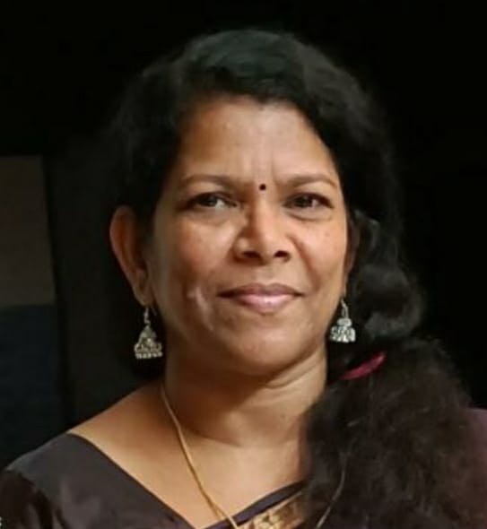

- General Information
Name | PRASANNA P K
Designation | Associate. Professor
Qualification | MA, B Ed,
Research
Contact No. | 9846783400
E-mail ID | pkprasannaprakasan@gmail.com
Any Other

- Educational Qualifications

Course | Board/University | Institution | Year | Remarks
S S SLC | Board of Public Exams., Kerala | RHS Thumboor | 1982
Pre Degree | University of Calicut | St. Joseph’s College, Irinjalakkuda | 1984
B A Economics | University of Calicut | St. Joseph’s College, Irinjalakkuda | 1987
M A Economics | University of Calicut | Vimala college, Thrissur | 1989
B Ed  (English) | MG University | SNM Training College, Moothakunnam | 1991

C Research Details

 | Ph.D
Title | Dependency issues of Elderly Women: A Study of Thrissur District
Guide | Dr. Visakh Varma
No. & Date of Registration | 1372/2009 dated 17/03/2009
University | MG University
Date of Submission of thesis
Awarded or Not | Continuing

D SERVICE DETAILS

Date of Joining in the Govt. service | 06/12/1993
Date of Joining in the present post | 06/12/1993
PEN | 608068
SDO CODE  Additional charges | Vice Principal  Head of the Department  Convener- Grievances Redressal Cell  PTA Secretary 2016-2018  Discipline Committee Convener 2016-2018  Convener_ Anti-Ragging Committee  Member-Women cell  Principal in Charge with financial power from 01/11/2017-02/01/2018, 18/06/2019-31/07/2019, 05/09/2020-08/11/2020  Planning Committee member  Member- Library Committee  Member- NAAC  Co-ordinator- Internal Complaints Committee
Additional Duties | Member- PG Board of Studies from 2016 onwards  Subject Expert- Screening cum Evaluation Committee meeting for the CAS promotion of Teachers  Chairperson- BA UG Valuation camp  External Examiner of PG project viva

- Orientation & Refresher Courses Attended

Year | Course | Date(From – to) | Duration |  | University
2002-2003 | Orientation | 27-08-2002 to 23-09-2002 | 28 days |  | ASC, University of Kerala
1995-1996 | Refresher course in Economics | 16-03-1995 to 06-04-1995 |  | 21 Days | ASC- HRDC, University of Kerala
1999-2000 | Refresher Course in Economics | 01-03-1999 to 22-03-1999 |  | 21 days | Department of Economics, GVC Palakkad
2009-2010 | Refresher in Environmental Studies | 10-09-2009 to 30-09-2009 |  | 21 days | ASC-University of Calicut

- SEMINARS/WORKSHOPS PARTICIPATED

Year | Seminar/Workshop  (Sponsoring Agency | Topic | Date & Year | Institution
2015-16 | IMG Training | Management Development Program for Principal? Vice Principal | 10—8-2015 to 13-08-2015 | IMG Calicut
 | National Seminar | Post Keynesian Developments in Macroeconomics, Gaps in Theory and Practice: Retrospection in the contemporary Global Economic Order | 18, 19 Jan 2016 | PG Dept of Economics  DCE sponsored
 | National Workshop | Data Analysis Using SPSS | 09,10 March 2016 | Dept of Economic, SNGSC Patttambi
2002-2003 | National Seminar | Money and Finance | 28,29 Nov 2002 | Christ College, Irinjalakkuda
 | Seminar | Research Methodology & Books in the 21st Century | 24 Jan 2002 | National Book Trust of India, New Delhi & SNGS College, Pattambi.
 | Annual Regional Science Conference | Science | 25,26 Oct 2002 | Dept of Economics. Dr. John Mathai Centre, Thrissur
2009-2010 | National Seminar | Women and Globalization | 19,20 Oct.2009 | Department of Economics, Sri. Achutha Menon Govt College, Thrissur
2019-2020 | National Workshop | Data Analysis using R software | 22.23 Nov 2019 | Dept of Economics, Krishnan Menon Memorial Govt College, Kannur  DCE sponsored
 | Sasthrapadham | Management Science enrichment residential camp |  | DCE & Department of General Education, Kerala  At SNGS College, Pattambi
2018-19 | National Seminar | Quantitative Techniques in Social Science Research | 24,25,26 Sept 2018 | GVC, Palakkad

Achievements in academic activities other than teaching and Research

SI No | Topic or area | Period | Present status
Major and Minor Research Projects
Publications
Others

