TEACHERS PROFILE
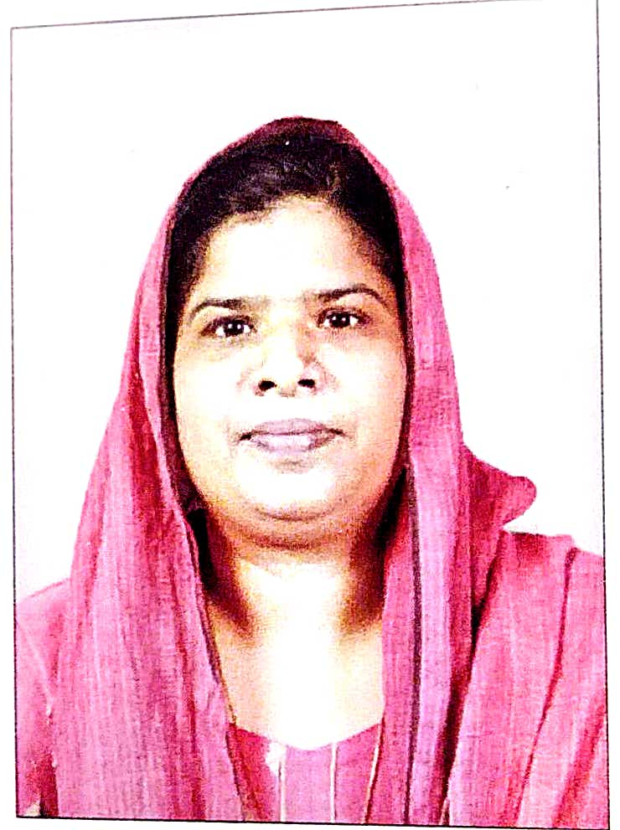
- General Information

Name | JAMEELA.K
Designation | Asst. professor
Qualification | MA, B Ed, NET
Research
Contact No. | 9744494937
E-mail ID | 83jameela@gmail.com
Any Other

B. Educational Qualifications

Course | Board/University | Institution | Year | Remarks
S S SLC | Board of Public Exams., Kerala | Govt High school,Koppam | 1998 | First class
Pre Degree | University of Calicut | S.N.G.S College Pattambi | 2000 | Second Class
B A Economics | University of Calicut | S.N.G.S College Pattambi | 2003 | First class
M A Economics | University of Calicut | S.N.G.S College Pattambi | 2005 | First class
B Ed  (Social Studies) | University of Calicut | Farook Training College | 2007 | First class
NET | UGC |  | 2007
PhD | University of Calicut |  | 2019 | Doing

C Research Details

 | Ph.D
Title | Intergenerational Employment mobility of women among muslim community in Kerala.
Guide | Dr.Reji Mon PM
No. & Date of Registration | UO.No.12976/2019/Admn
University | Calicut university
Date of Submission of thesis | 16.08.2025
Awarded or Not | doing

D SERVICE DETAILS

Date of Joining in the govt service | 01/12/2011
Date of Joining in the present post | 01/12/2011
PEN | 663385
SDO CODE  Additional charges | 88477  IIMA Tutor
Additional Duties

- Orientation & Refresher Courses Attended

Year | Course | Date(From – to) | Duration |  | University
2008-09
2009-10
2010-11

2011-12

2012-13

2013-14

2014-15 | Orientation | 26/11/201 to 23/12/2014 |  | 28 Days | ASC, Calicut University
2015-16
2016-17 | Refresher | 11/05/2017 to 31/05/2017 |  | 21 days | ASC, Calicut University
2017-18
2018-19
2019-20
2020-21 | 1.Short term  2.Refresher  3.Shorterm | 23.09.2020 to 29.09.2020  20.07.2021 to 03.08.2021  10.08.2021 to 16.08.2021 |  | 7 days  14days  7days | UGC,HRDC Kerala University  TLC,Ramanujan College,University of Delhi  TLC,Ramanujan College,University of Delhi

- SEMINARS/WORKSHOPS PARTICIPATED

Year | Seminar/Workshop  (Sponsoring Agency) | Topic | Date& Year | Institution
2007-08  2009-10  2009-10  2010-11  2011-12  2012-13  2013-14  2014-15  2015-16  2016-17  2017-18  2018-19  2019-20  2020-21 | Dept.of collegiate Education  Dept.of collegiate Education  Dept.of collegiate Education  1)Dept.of collegiate Education  2) Dept.of collegiate Education  Directorate of Collegiate Education,Govt.of Kerala  Directorate of Collegiate Education,Govt.of Kerala  2)Directorate of Collegiate Education ,Govt.of Kerala  3) Directorate of Collegiate Education ,Govt.of Kerala  Nil  Directorate of Collegiate Education ,Govt.of Kerala.  Directorate of Collegiate Education ,Govt.of Kerala.  1) Directorate of Collegiate Education ,Govt.of Kerala  2)Directorate of Collegiate Education ,Govt.of Kerala.  3.AKGCT  4.Govt.arts and science college Kozhikkode | National seminar on Goods and service tax in  India-prospets and issues  National seminar on Applications of Econometrics in socio-Economic Research.  1)National seminar on Indian Monetary Regime under Liberalisation:Rhetoric and Reality.  National seminar on Accreditation of Higher Education Institutions:Processes &Methodologies.  Data Analysis for social science Research  Fostering Linkages in Academic Innovation and Research  Basic Tools in Social Science Research  Short term training programme on Course Design  National Workshop on Statistical Data Analysis Using R  National Seminar on Structural Transformation in the Indian Economy :Trends,Patterns and Implications  Time of Serious Economic Turmoil:Role of Economics And Economists  National Workshop on Statistical Data Analysis Using R Software  National Seminar On Public Funded Education Under NDA Two  Webinar on Disconnect between Theory and Reality:Insight from Behavioural Economics | 31st January and 1 st february,2012  28&29 November,2012  25 th October 2013  6 th November 2013  20th and 21st January 2015  17.09.2015 to 19.09.2015  30 th November and 1st and 2nd December 2015  18-22 January 2016  4th and 5th  December 2017  30.10.2018&31.10.2018  28&29 October 2019  22nd  And 23rd November 2019  6th March 2020  29 January 2021 | S.N.G.S COLLEGE PATTAMBI.  S.N.G.S COLLEGE PATTAMBI  Govt.college Kodenchery  Govt.college Kodenchery  Govt.college kodanchery  Ashir Bhavan,Ernakulam  Govt.Arts and Science College,Kozhikkode  International Institute of Information Technology,Bangalore.  Govt.Victoria College Palakkad  S.N.G.S College Pattambi  S.N.G.S College Pattambi  KMM Govt.Women,s College Kannur.  Town hall,Thrissur  Govt Arts and Science College,Kozhikkode

Achievements in academic activities other than teaching and Research

SI No | Topic or area | Period | Present status
Major and Minor Research Projects
Publications | 1.Study material for Distance Education students of Calicut University  2.Current Status of Muslim Women Education and Occupation In Kerala | 2011 admissions  Vol.19 Issue 1 Month May year 2020 | CUP/9122/12/750-263/SDE-1  Article in the UGC care Journal
Others | Appointed as the question paper setter for BA &MA Degree programme of Farook College | March 2018 | Farook College

