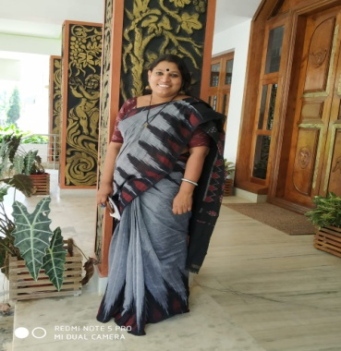 BIODATA

1. PERSONAL DETAILS
Name : RAJITHA C R
Designation : Assistant Professor
Department : Commerce
Permanent Address : Chirammal house,
Attathara,PIN 680590
Date of birth and Age : 30/04/1985, 36 YRS
Mobile No. : 8907622073
Email ID : rajithajohny@gmail.com

II EDUCATIONAL QUALIFICATIONS
Course | Subject | University/Board | Year of passing | % of marks
NET,JRF | Commerce | UGC | 2007
M.Com | Commerce | Calicut | 2007 | 70
B.Com | Commerce | Calicut | 2005 | 68
Plus two | Commerce | Higher secondary education ,Kerala | 2002 | 76
S.S.L.C |  | Kerala Board | 2000 | 68

III PROFESSIONAL DETAILS
Date of Entry in to service | 3.12.2013
Previous Service | NIL
Academic /Teaching Experience | PG Level: 8 years  UG Level: 8 years
Area of Specialization | Marketing
Courses Taught  Post Graduate level:  - International Business  - Financial Market and Institutions | Graduate level:  - Managerial Economics  - Management Concepts and Business Ethics  - Human resource management  - Banking and Insurance  - Business Research Methods  Operations mangement  - Business regulations
Research Experience | Doing Ph.D.
Highlights of Professional Experience | Nil
Professional Affiliations | NIL
Academic Honors & Awards | Nil

Conference/Seminar/Workshop Presentations

20172017

Presented a paper titled "Farm tourism entrepreneurship:A catalyst for rural development of Kerala”at the two day National conference on" Contemporary Research and practices in Tourism and Hospitality"conducted on 5th and 6^{th May} 2017 by the Dept of TourismStudies, Pondicherry University

Conferences/Seminars/Works.hops Attended

Selected Publications | NIL
IV. Other Activities
Additional Responsibilities PTA Executive member
Staff Advisor
Member women cell
Member Anti -raggingcommittee

- Other Information:

NIL

